

Dr. Christopher, Wagner inc.
2015-02-09
Dr. Wagner
4301 Anthony Center, New Erika, IA 00525
Phone: 929601965
Fax: 4669672490

Re: Kathleen, Fox
PHN: 2045906504
Birthdate: 13-Sep-1987
Address: 3352 Hudson Club, Donnaton, FL 50769
Patient number: 9223436534

To Whom It May Concern:

This is a medical letter to state the above patient is pregnant with expected delivery date of 25-Aug-2025. Hoping this information is satisfactory for your requirements.

Thank you.

Sincerely,
Dr. Christopher, Wagner
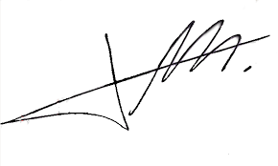
FRCS© NCMP
Clinical Assistant Professor, UBC
Department of Obstetrics and Gynecology SMH

